R-1.7

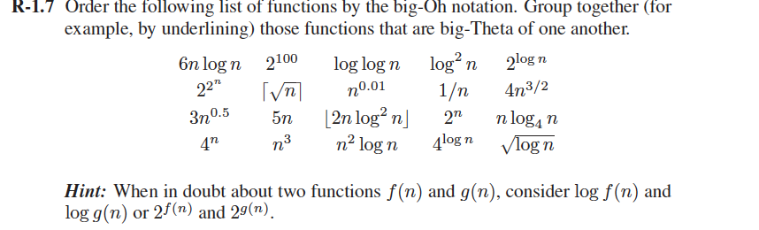

Answer:

1. 1/n
2. 2100
3. (log n)0.5
4. log2n
5. n0.01
6. n0.5,3n0.5
7. 2logn,5n
8. n log4n, 6nlogn
9. 2nlog2n
10. 4 n3/2
11. 4log n
12. n2 log n
13. n3
14. 2n
15. 4n
16. 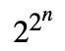

R-1.9

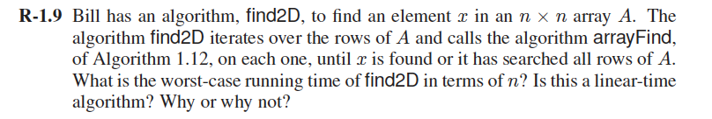

Answer:

The worst case running time of Find2D is O(n2). Because the worst case is that the element x is at the last position in the n\*n array, thus find2D will call the arrayFind n times and do n comparisons for each arrayFind call. The running time is O(n2).

This is a linear time algorithm. Because the running time will be proportional to its input size n\*n.

R-1.22

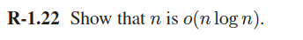

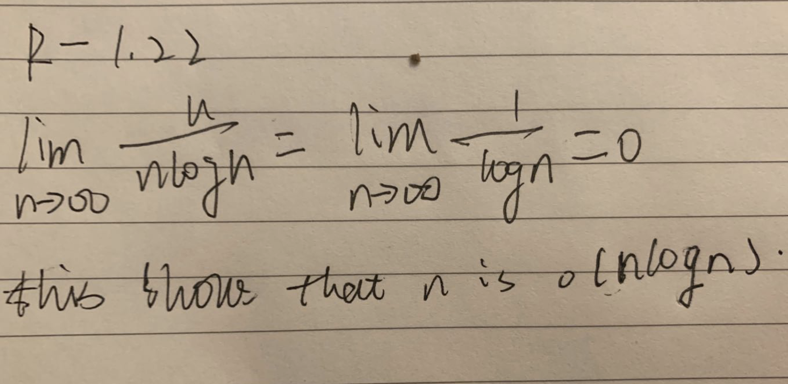

R-1.23

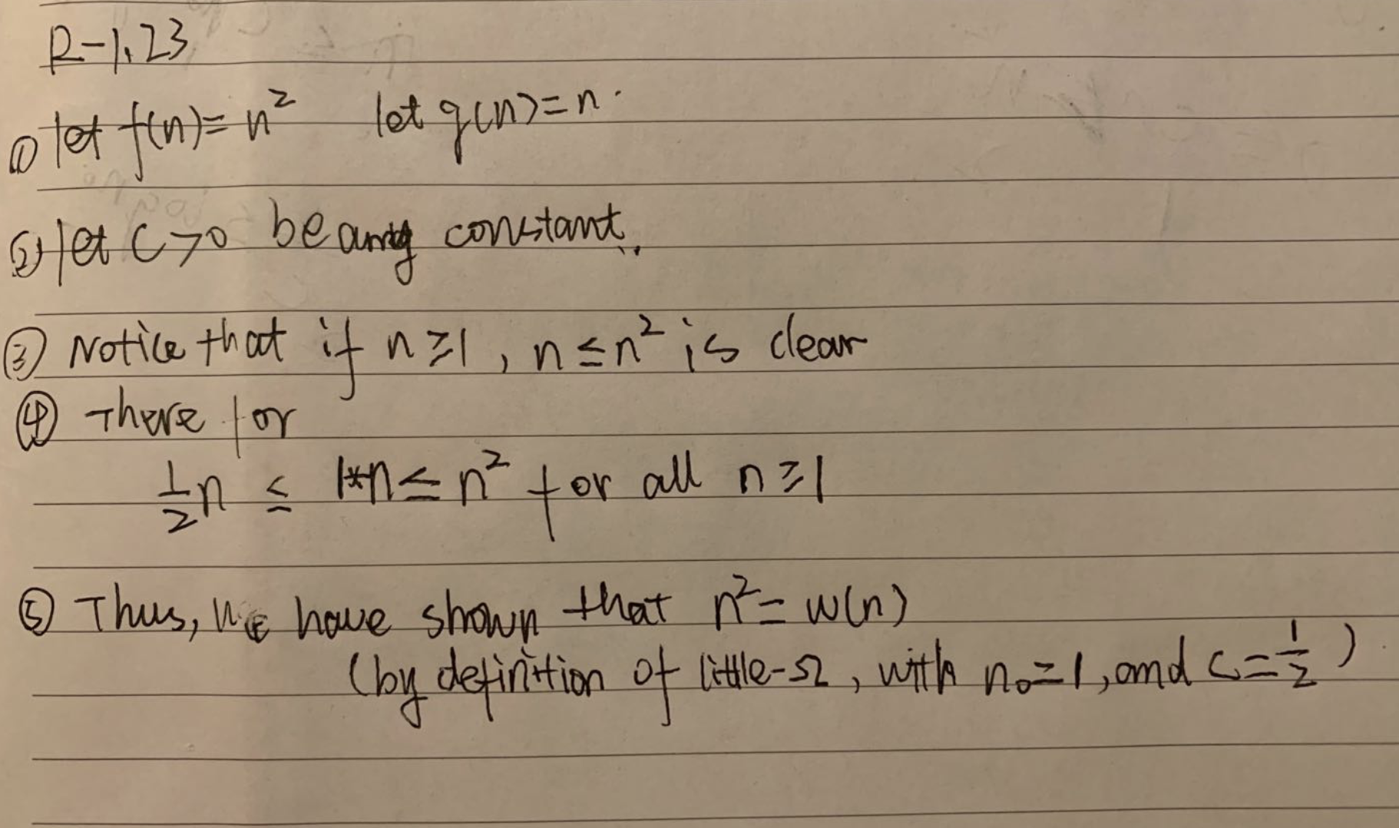

R-1.24

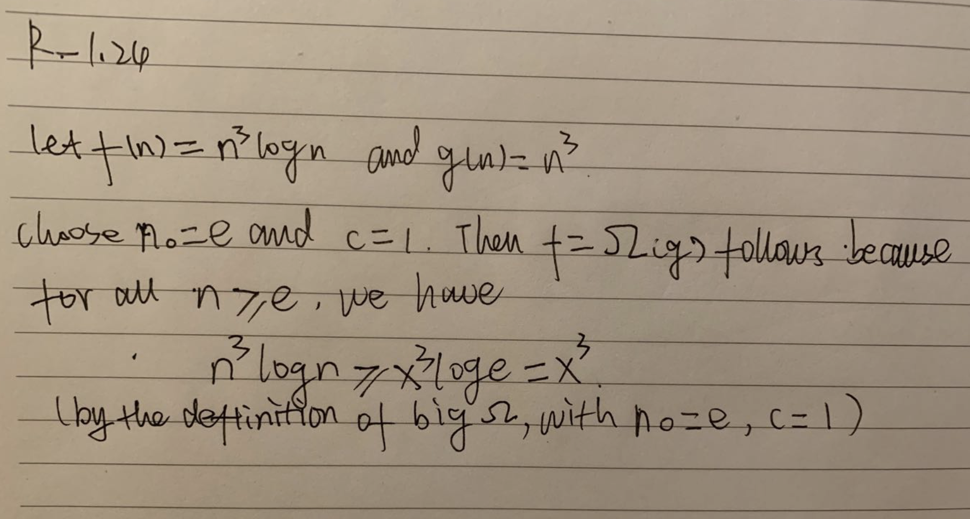

R-1.32

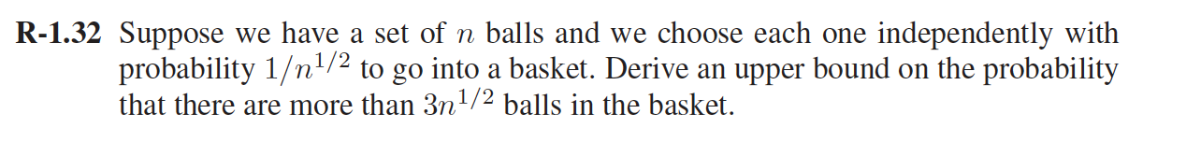

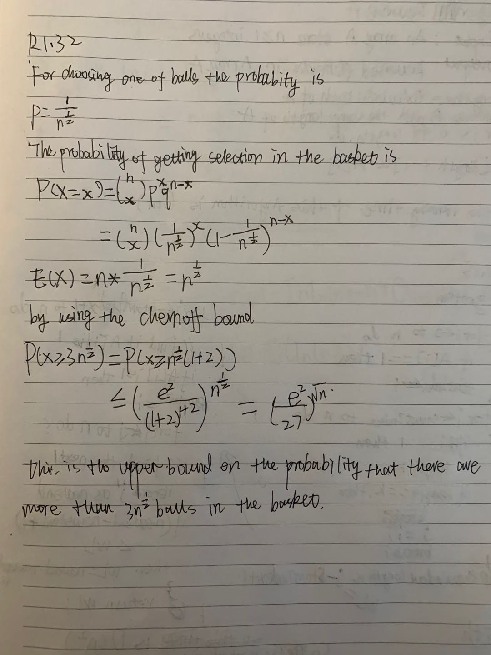

C-1.4,



Awser:

The problem can be seen as how many time there is a bit that changes.

Take the n=2x as an example:

let x = 3, we count one bit position at a time:

* The first bit position which is ones changes for every number,so it flips n times
* The second bit position which is twos changes for every second number, so it flips n/2 times
* The third bit position which is fours changes one time out of four so it flips n/4 times.

And so forth, the total number of flips is

$\sum_{i=1}^{x}{(n/2^}i)$ = n $\sum_{i=1}^{x}{(2^-i})$ < 2n

So the total running time of counting from 1 to n in binary is O(n).

C-1.7,

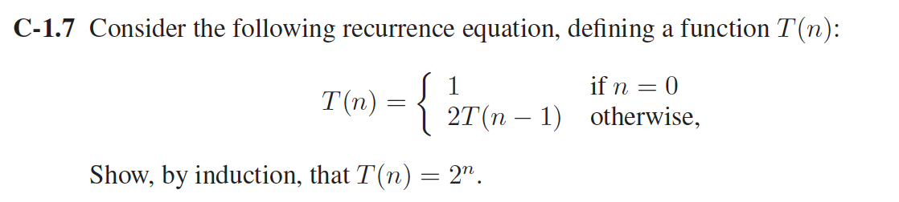

Answer:

Base case n =0: T(0) = 1 by definition and 20 = 1 when n = 0, thus T(n) = 2nwhen n =0.

Induction step

Induction hypothesis: Assume T(k)=2k for some arbitrary integer k not equal 0 . Then we will show that it must hold for the next integer,k+1,as well.

By definition T(k+1) = 2T(k). By the induction hypothesis, T(k) = 2k, thus T(k+1) = 2\*2k=2k+1. Hence, the result holds for n = k+1 and by induction must therefore hold for all n.

C-1.22,

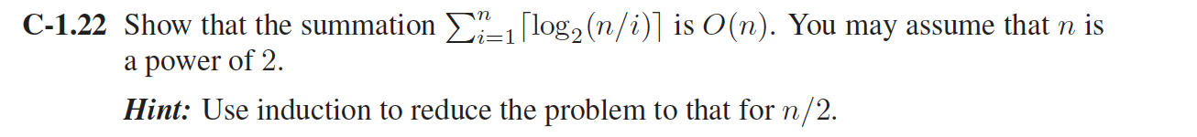

Answer:

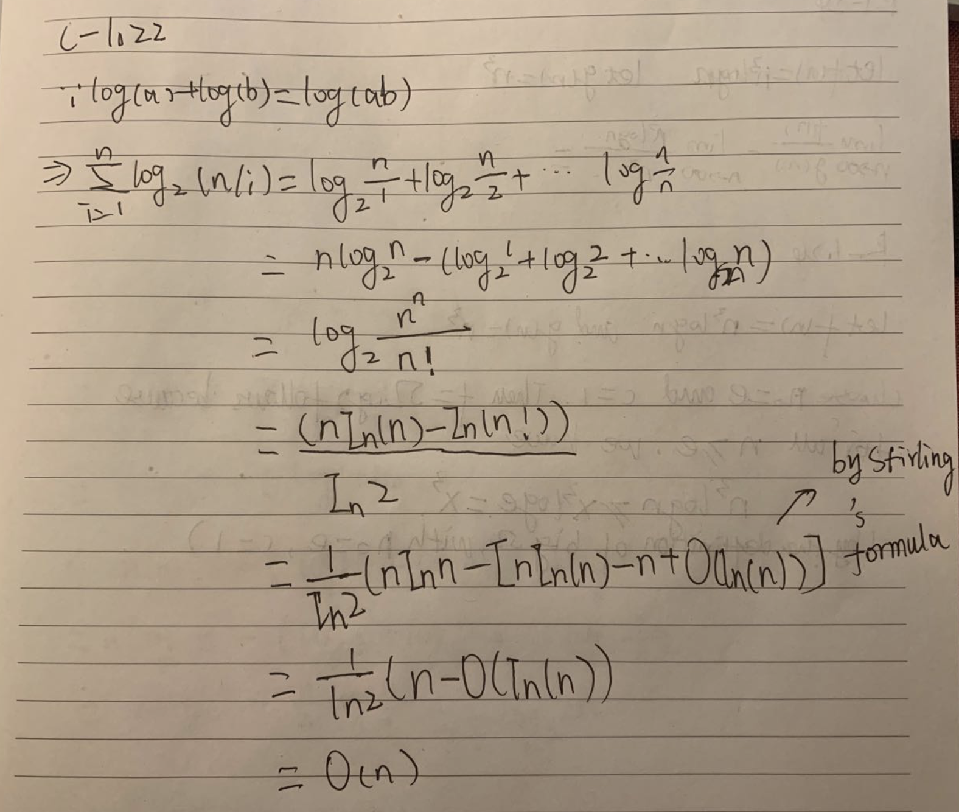

C-1.30,

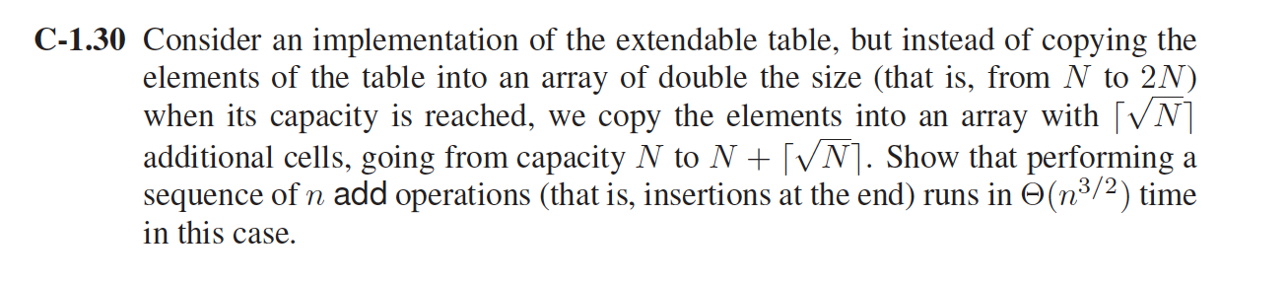

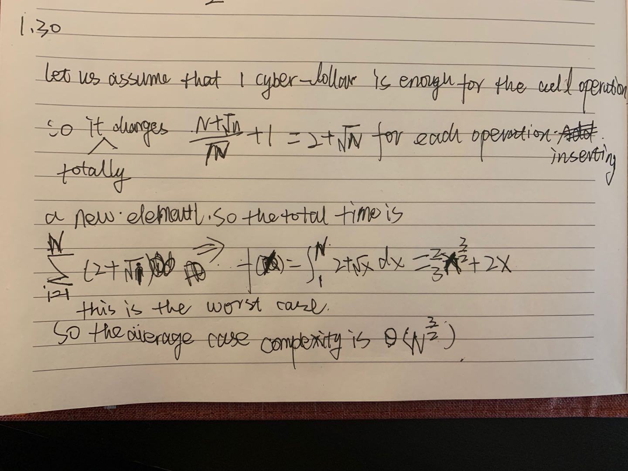

A-1.8,

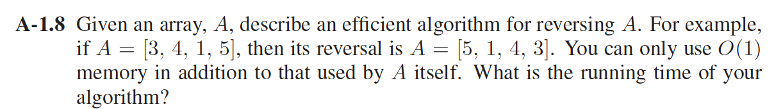

Answer:

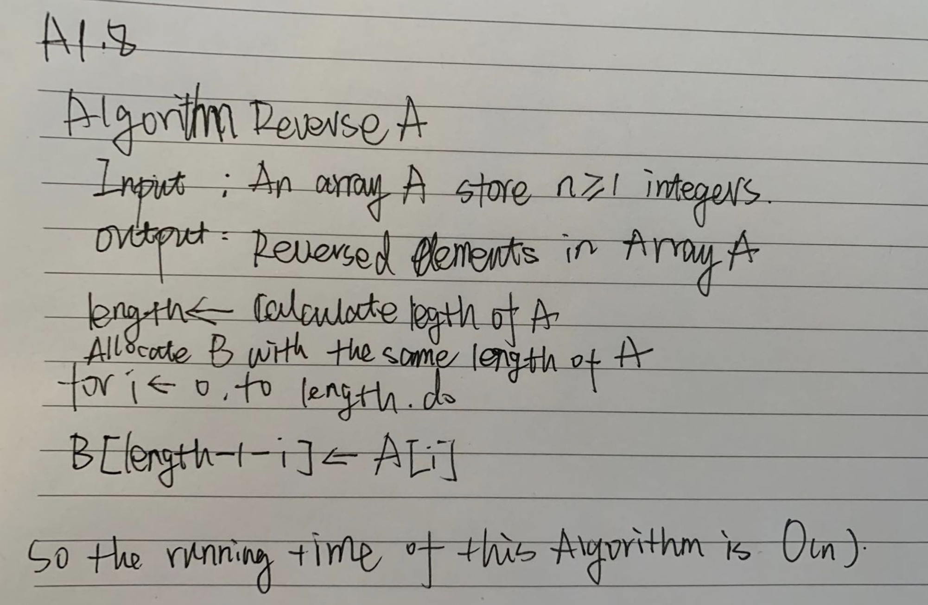

A-1.15

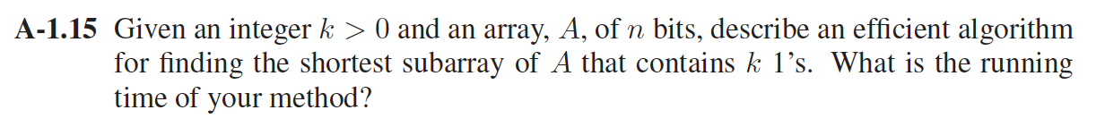

Answer:

